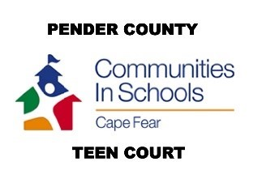

2024-2025

Teen Court Volunteer Form

Name______________________________________ Date of Birth______/______/______

Address______________________________City___________________________Zip___________

School___________________________________________Race_______Sex______Grade_______

Student Telephone (Cell)_____________________________________ T-Shirt Size: ______________

E-Mail _________________________________@________________________________________________
**This needs to be an email that you and/or your parent/guardian checks regularly**

Parent/Guardian Name___________________________________________________________
Your participation requires a commitment to not only to Teen Court, but also your school and your peers. This commitment includes:
* Attending Teen Court Hearings at the times and places scheduled
* Attending training sessions
* Demonstrating the ability to treat each case impartially, with objectivity and without prejudice
* Maintaining absolute confidentiality and courtroom behavior- quiet, respectful, no laughing/snickering, etc.
* Participating for one school year but not being limited to that year
* Accepting personal responsibility for actions while a member of Teen Court. If the Teen Court Coordinator
considers your behavior unacceptable, your parents will be contacted and, you could be dismissed as a volunteer.
* You must dress professionally the night of court: business casual clothing should be worn (no tshirts/sweatshirts/jeans/leggings/sneakers)

For Parents/Guardians:
Your teen’s involvement in Teen Court may require some involvement on your part. It may require that transportation be made at the scheduled times or accessibility to the internet and a location where privacy and be maintained. If you have transportation issues, Teen Court may be able to assist in getting your student to and from Teen Court.

I give permission for ______________________________to receive training as a Teen Court participant. I will also support my teen’s participation in the program by helping ensure that they honor their commitment and responsibility (as outlined above) to the Teen Court program. Furthermore, I give my consent for my youth’s photograph and/or likeness to be used by Communities in Schools for publicity and/or training materials.

_________________________________(____)________-___________ __________________
Parent’s or Guardian’s Signature/PHONE #(In case of emergency) Date

When application is completed, please return to:
penderteencourt@ciscapefear.org, your school representative or make alternative arrangements.

Questions? Contact Carrington Kennelly at 910-317-9064 or penderteencourt@ciscapefear.org

